**Introduction**

In order to optimise the growth of the ice formation throughout the winter, and understand its melt in the spring and summer, it is crucial to understand how various environmental parameters influence the freeze and melt dynamics.

I have created a data analysis and modelling pipeline to elucidate the effect of the different parameters measured by the weather station namely temperature, relative humidity, wind speed. Using machine learning algorithms, I have matched these parameters to changes in the height of the stupa, measured from images snapped by the same weather station (height was manually measured in pixels from the images, and extrapolated the pixel dimension to a metric one based on a few reference frames). Also periods of fountain water flow were determined using the images. The timelapse video can be found [here](https://youtu.be/RqA4yrPZghE).

Unfortunately, the results suffer from a low sample size in the measurements, and a data deficit especially due to irregular water supply and unavailability of fountain water discharge data.

**Val Roseg Ice Stupa**

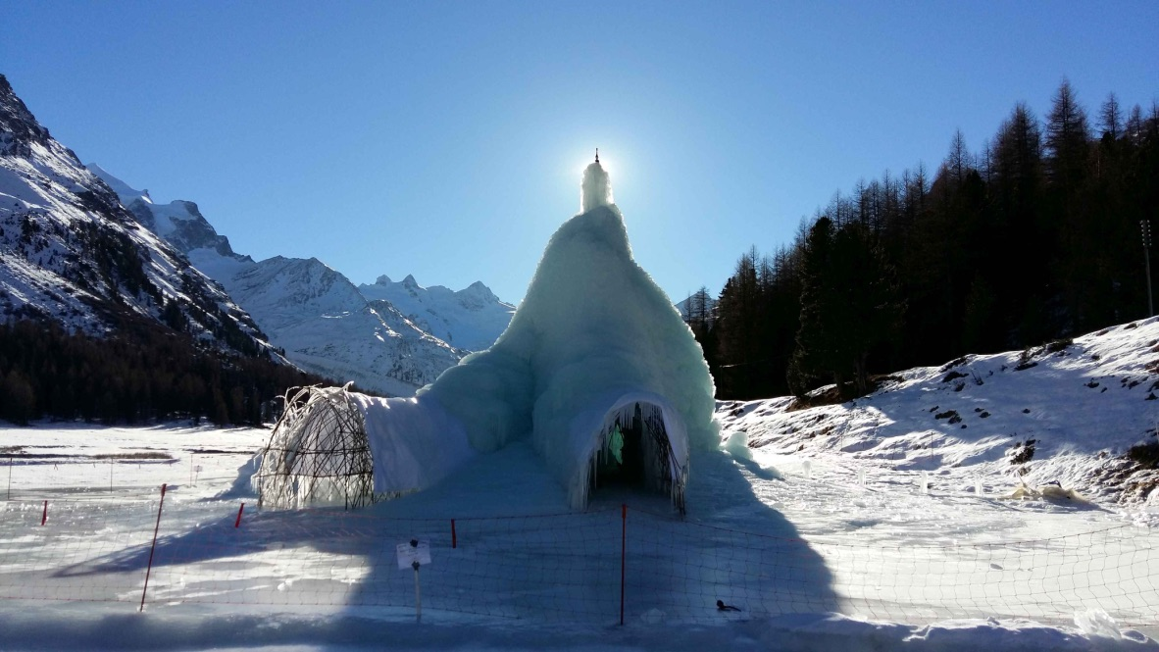

**Methods and data**

All the data used comes from Utrecht’s Automatic Weather Station installed by Wim. There was also a high resolution timelapse camera as part of it which took day time photos every 2 hrs from 9am to 4pm. The weather data with 5571 records spanned from 17th November to 7th July. The timelapse imagery with records was selected upto 8th April as the Ice Stupa wood skeleton was exposed by then. All the files of this project can be accessed at [Github](https://github.com/Gayashiva/Val_Roseg).

To extract the height in metres, every peak point of the timelapse was marked and then the height was estimated. The reference image shown below was used to map this data into height assuming the person to be 6 ft tall.

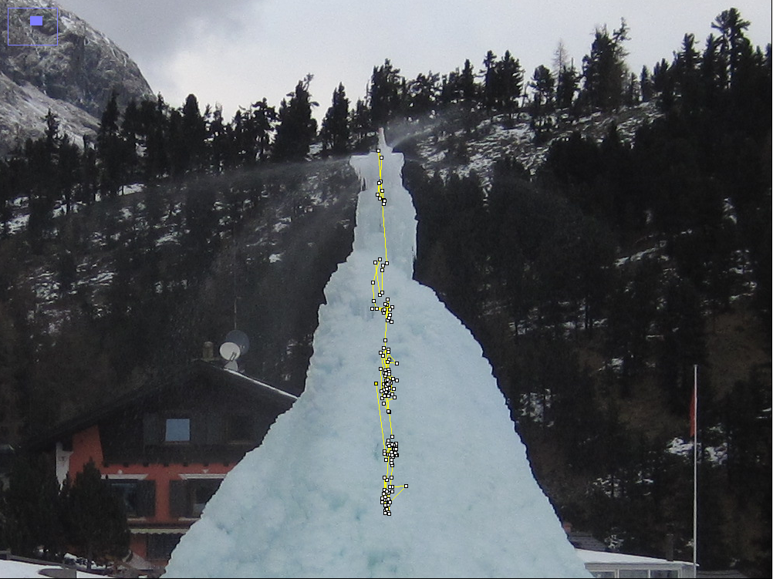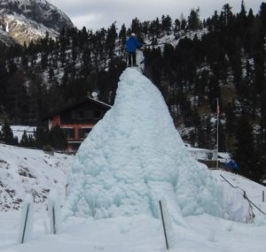

Figure 1 Showing the manual selection of peak points and the reference image to map pixels to metres

**Data selection and analysis**

Therewere 3 steps to this each with their own online notebook:

1. [Data extraction and selection from the timelapse imagery and AWS](https://github.com/Gayashiva/Val_Roseg/blob/master/notebooks/data_refining.ipynb)
2. [Fountain Water flow analysis](https://github.com/Gayashiva/Val_Roseg/blob/master/notebooks/Water_IO.ipynb)
3. [Multivariate Regression Analysis](https://github.com/Gayashiva/Val_Roseg/blob/master/notebooks/Analysis.ipynb)

Please refer the respective notebooks for full details of the process. A brief overview of the steps taken and my observations are also present in the notebook. In the next version I will summarise all of that in the report.



Figure 2 Temperature and Height of the ice stupa in the winter and spring of 2016, extrapolated from images; Note the orange binary steps represent fountain on/off state

**Summary**

Below are all the model results that were presented in the notebooks. After some cleaning I was able to relate 61 morning (around 8am) and 94 evening (around 4pm) measurements to the preceding 12 hours of environmental measures (5571 data points in total). Analysis of the data points revealed that the Ice Stupa reached a maximum height of 9 m using approximately 1540 cubic metres of water in a period of 17 days. This indicates a freezing efficiency of 14 percent assuming the fountain discharged 0.5 litres/s when in operation.

I was able to establish trends regarding how the growth (positive for freeze, negative for melt) relates to the three remaining parameters: temperature, relative humidity, and wind speed. The measurements show such a level of noise though, that any correlation should be taken with caution. For example, the measured positive correlation between average temperature and day growth would become negative (which would be more sensible) if the most extreme outliers were removed. The fountain pipe manual extensions were recorded as high growth rates for example. The results below are provided for illustrative purposes only.

The final modelling step consisted of fitting a multivariate linear regression model to understand the respective influence of each parameter, taking into account existing collinearity. As each parameter comes as a time series (12 hours), I also created modelling features representing the dynamics of the time series (in addition to average): minimum value, maximum value, and standard.

For fitting the data appropriately it was first separated as day and night values to include the contribution of sunlight and later only the data points which had the fountain functioning were observed to remove the scenarios of natural precipitation. Unfortunately, the fit still is quite poor: the coefficients of determination R2 are 0.14 for the night, and 0.13 for the day.



Figure Respective weight of the different features in the multivariate regression models

For both time periods (day and night), the regression quality is poor to moderate. This could be improved further by including precipitation and LW radiation later. Also exact measurements of fountain discharge should greatly influence quality of fit. It is possible that a latent factor (e.g., flow increased due to high enough temperature) is ignored here.

We observe that high temperatures lead to high melt rates. The second most important feature is the relative humidity, which needs to be kept sufficiently high (the minimum level is determinant) to ensure good freeze. Other features are comparatively less significant.

Much of the model's descriptive power seems to be linked to a high estimated weight of instantaneous temperature. Over the course of the day: the more the temperature increases, the faster the ice stupa melts. The relationship is not trivial, and may underline the effect of a latent, unobserved variable which may indicate that temperature fluctuations lead to structural fragmentation of the ice stupa. My general conclusion is that this modelling workflow should be replicated on more and better measurements in the coming winter.

**Discussion**

In the future we could use thermal cameras to record pixel wise temperature data in the Ice Stupa timelapse imagery. This could help us assign probability of melt and freeze to every pixel based on its surface temperature and other parameter history. Also the pixel area of the Ice Stupa(or volume) can be obtained which is a much better parameter than height.

Periodic water flow in the pipeline could be obtained through a flowmeter. This could help us account for variations in fountain discharge.

The daily melt water could be collected and measured.

The fountain pipe needs to be of fixed height throughout the period of installation to avoid growth spikes.

The internal microclimate of the Ice Stupa also needs to be studied. Particularly the Ice Stupa room cavity can influence the freeze and melt behavior.